CSA0501-DATABASE MANAGEMENT SYSTEMS
LAB EXPERIMENTS DATE: 18/07/2026

EXPERIMENT 6 -- SELECT with BETWEEN, IN and Aggregate Functions

AIM:
To view records from the Flight Reservation System tables using SELECT statements with BETWEEN, IN and Aggregate functions.

PROCEDURE:
1. Open MySQL Workbench and select the Flight_Reservation database.
2. Ensure the Flight, Booking and Payment tables contain records.
3. Execute SELECT queries using IN and BETWEEN operators.
4. Execute aggregate functions such as AVG, MAX, MIN, SUM and COUNT.
5. Verify the output after each query.

PROGRAM:
IN & BETWEEN - 1
SELECT * FROM Flight
WHERE Destination IN ('Delhi','Mumbai');
OUTPUT:
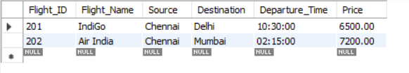

IN & BETWEEN - 2
SELECT * FROM Flight
WHERE Price BETWEEN 6000 AND 8000;
OUTPUT:
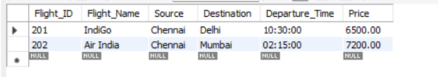

AGGREGATE - 1
SELECT AVG(Price) AS Average_Price
FROM Flight;
OUTPUT:
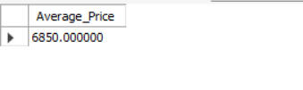
AGGREGATE - 2
SELECT MAX(Price) AS Maximum_Price,
MIN(Price) AS Minimum_Price
FROM Flight;
OUTPUT:
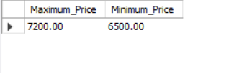

AGGREGATE - 3
SELECT Destination,
MAX(Price), MIN(Price), AVG(Price)
FROM Flight
GROUP BY Destination;
OUTPUT:
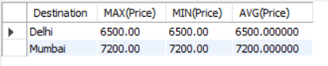

AGGREGATE - 4
SELECT Destination, AVG(Price)
FROM Flight
GROUP BY Destination;
OUTPUT:
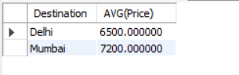

AGGREGATE - 5
SELECT SUM(Amount) AS Total_Amount
FROM Payment;
OUTPUT:
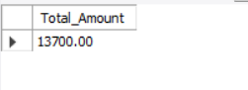

AGGREGATE - 6
SELECT Flight_ID, COUNT(*) AS Total_Bookings
FROM Booking
GROUP BY Flight_ID;
OUTPUT:
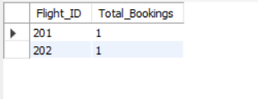

AGGREGATE - 7
SELECT Passenger_ID, COUNT(*) AS Total_Bookings
FROM Booking
GROUP BY Passenger_ID;
OUTPUT:
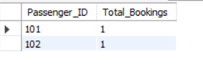

RESULT:
Thus, the records from the Flight Reservation System tables were successfully displayed using SELECT statements with BETWEEN, IN and Aggregate functions.

